

Ms. G. Mamatha
PERUGU MANISHA
2520030054
CSE
CO3

Case Study Topic: Airline Route Network Optimization using BFS, DFS, Prim's and Kruskal's Algorithms

Work Done Summary
In this case study, we implemented BFS, DFS, Prim's Algorithm, and Kruskal's Algorithm to analyze airline route networks.
BFS and DFS were used to traverse connected airports and explore flight routes. Prim's and Kruskal's algorithms were used to construct a Minimum Spanning Tree (MST) for minimizing airline route infrastructure costs while maintaining connectivity between airports.
The algorithms were compared based on traversal efficiency, network connectivity, and cost optimization. The study concluded that MST algorithms help airlines design cost-effective route networks while BFS and DFS assist in route exploration and connectivity analysis.

Implementation Details
BFS Traversal
- Started traversal from a source airport.
- Visited neighboring airports level by level.
- Used a queue for processing.
- Verified network connectivity.
DFS Traversal
- Started traversal from a source airport.
- Explored routes deeply before backtracking.
- Used recursion/stack.
- Identified connected airport clusters.
Prim's Algorithm
- Constructed Minimum Spanning Tree.
- Selected minimum-cost edges.
- Connected all airports with minimum infrastructure cost.
Kruskal's Algorithm
- Sorted routes by cost.
- Added edges without forming cycles.
- Generated an MST with minimum total cost.

Result :Screenshots / Output
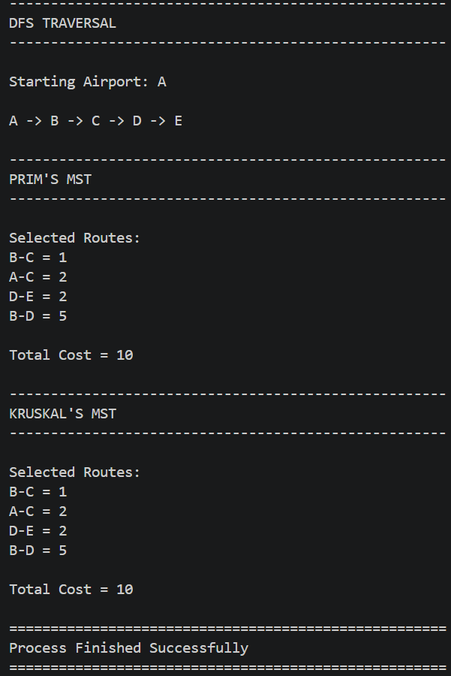
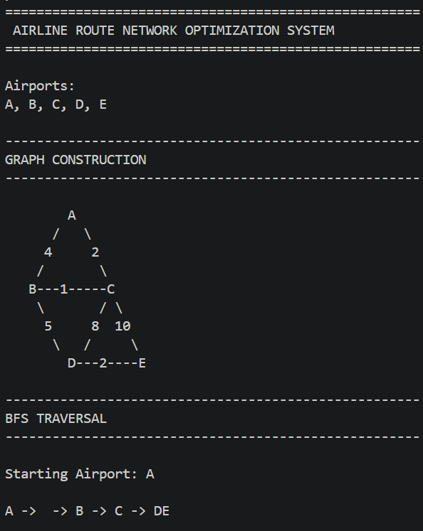

Conclusion
The study demonstrated the use of graph traversal and MST algorithms in airline route planning. BFS and DFS efficiently explored airport connectivity, while Prim's and Kruskal's algorithms minimized route infrastructure costs. These algorithms are widely used in airline network design, airport connectivity planning, and transportation infrastructure optimization.

GITHUB LINK: https://github.com/manishaperugu49-glitch/2520030054-DSA_2_CaseStudy_CO3

